1.

(d) 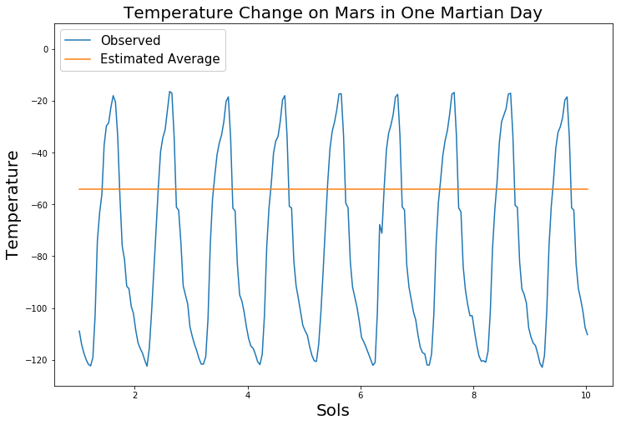

By observing the graph above, we can tell that the temperature on Mars is changing rapidly but periodically. The average temperature we estimated (-54 degrees Fahrenheit) is higher than the actual average temperature on Mars. The average temperature on Mars is approximately -70 degrees Fahrenheit. Our estimate is about 15 degrees higher. This may be caused because we ignored the atmosphere of Mars. The atmosphere on Mars is very different from the Earth. It is made up mostly of carbon dioxide, nitrogen and argon gas that can hardly store energy compared to Earth’s atmosphere.